WHAT CAN I EXPECT OF A HOUSE CONCERT? A Grace 2017
A House Concert is a way of bringing people together for the purpose of sharing Quality music, food, deeper bonding and conviviality within your home space. House Concerts transcend normal gatherings of family & friends because they create a focused intimate listening space, as well as bring exposure to new ideas and stories of other lands & people. A House Concert offers music at a mutually comfortable volume - folks feel included because they can really hear and feel the warm ambience of real music.

So House Concerts are the ‘bringing together of Community‘- like we used to do in the pre-digital age around the radio, or previous to that, when the travelling minstrels came to town. Our house concerts invite audience participation, singing and a good chat afterward. You, ‘the audience’ are the integral ‘house’ equation of the concert and the music we play is chosen accordingly. Evenings are made more fun with shared food, wine, a potluck prior or dessert at the break. We love to boil up the ginger and spices a couple of hours in advance for a big warming spicy pot of chai which is offered free. Everybody loves this!

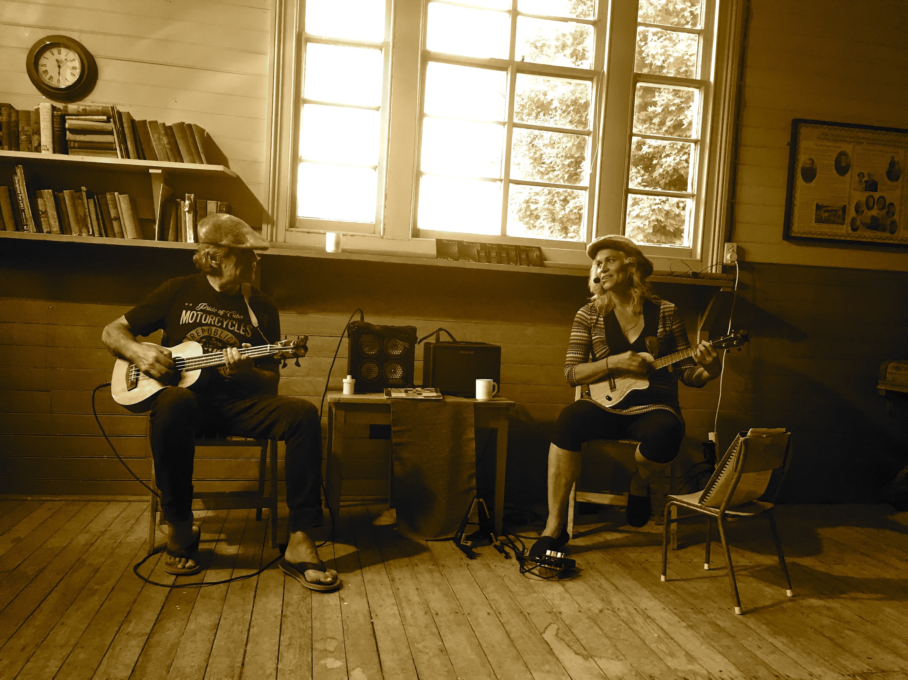
Laurie and Anu doing a house concert in an old school hall in Cambrian Sth Is, NZ, 2017.

So how does it all come together?

We talk through what kind of evening you want to create;
- max no. of people you’d be comfortable with (it’s surprising how many you can actually fit in your lounge-room with cushions and kitchen chairs, etc)
- food - potluck, just desert, BYO wine?
- what ‘feel’ would you like to create, etc.
You then talk to a couple of friends and see if there is interest and if so, we mutually set a date. You choose who you want there and have complete control of who enters your house. You can offer invitation’s via facebook or paper to your circle of friends with an R.S.V.P. for interest. It’s useful to compile a list of many possible invitees, thinking outside the square of your own tribe. Perhaps there is an old lady struggling with loneliness down the street, a new family in the neighborhood or a new work colleague you could invite. House Concerts are a great way to bridge the gap and there doesn’t need to be a huge number of people for it proceed. We recommend between 12 - 30 people in the room - so no stress on your part! We also don’t require any minimum cost to be covered by you!

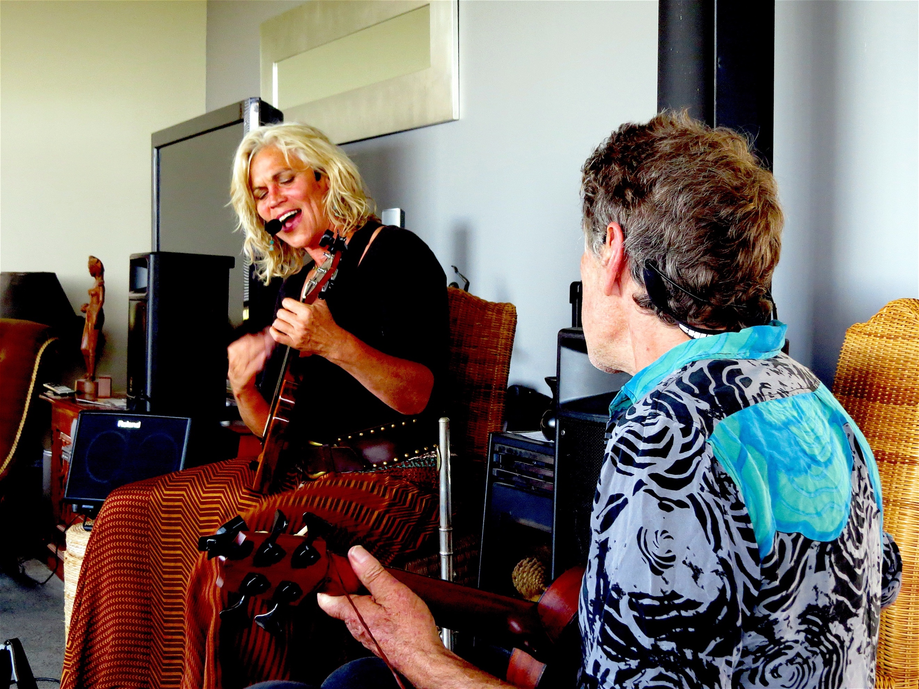
House concert at Avon’s, Auckland April 2017
Generally, hosts provide accommodation and a meal for the musicians for the night. We then come around in the afternoon before the concert to meet you and have a chat. We set up our sound gear (a minimal, yet quality setup) - sound-check our instruments, help arrange the room and put the chai spices on to bubble.

We then take a break, a shower, a nap even, and return about a half hour after your guests have arrived and have had time to “Howdy-do” and chat before show time ~ our later arrival creates a little intrigue and sets the scene for focused listening to follow!!

We play 2 x 45 min sets of music with a chai break in the middle. According to the demographic in the room, we try to mix in familiar songs, including old jazz in our original repertoire and singalong’s to enable your ears to rest on something familiar & sing along every now and then.

HOW DOES PAYMENT WORK?

As we travelled NZ we really came to see the value and effect these house concerts had. It was like creating a soul space I feel ‘we’ are really craving for. Given the fire lit in people’s eyes and the warm glow left in the room, we came to realise this was worth valuing at $20 -$25 per head as a general guideline. A night at the movies with no social contact, crap chips and too hard ice-cream, would cost you more and feed you way less. Our costs surprised us this last tour, even though we were hosted most of the time in people’s houses, paid no camping fees and stayed in a hotel only once. Life goes on and so does petrol, food, airfares, rates, ferry costs and payments that still had to keep coming out at home. Life was free and easy on the road but it wasn’t cheap! So $20 + a head seemed a reasonable expectation to set and affordable to most BUT certainly not mandatory ~ just a guideline!

This tour we are experimenting with a ‘trust’ donation at the end of the Concert when the vibe is all warm, rather than a cold upfront fee at the door. If you are amenable to this approach, we would ask you to make an announcement right as the last chord is still ringing “Thankyou so much … isn’t it great to have ‘live’ music in the loungeroom, and be able to meet new people, hear new songs and stories AND support real musicians to make a living” - ………”I’ll place the donation box here on this table and please give generously, buy a CD or two and enjoy the last of our supper together.” This also saves you having to account for any money. CD sales are important source of income for us and we often run a Uke or Singing workshop the next day to supplement our income.

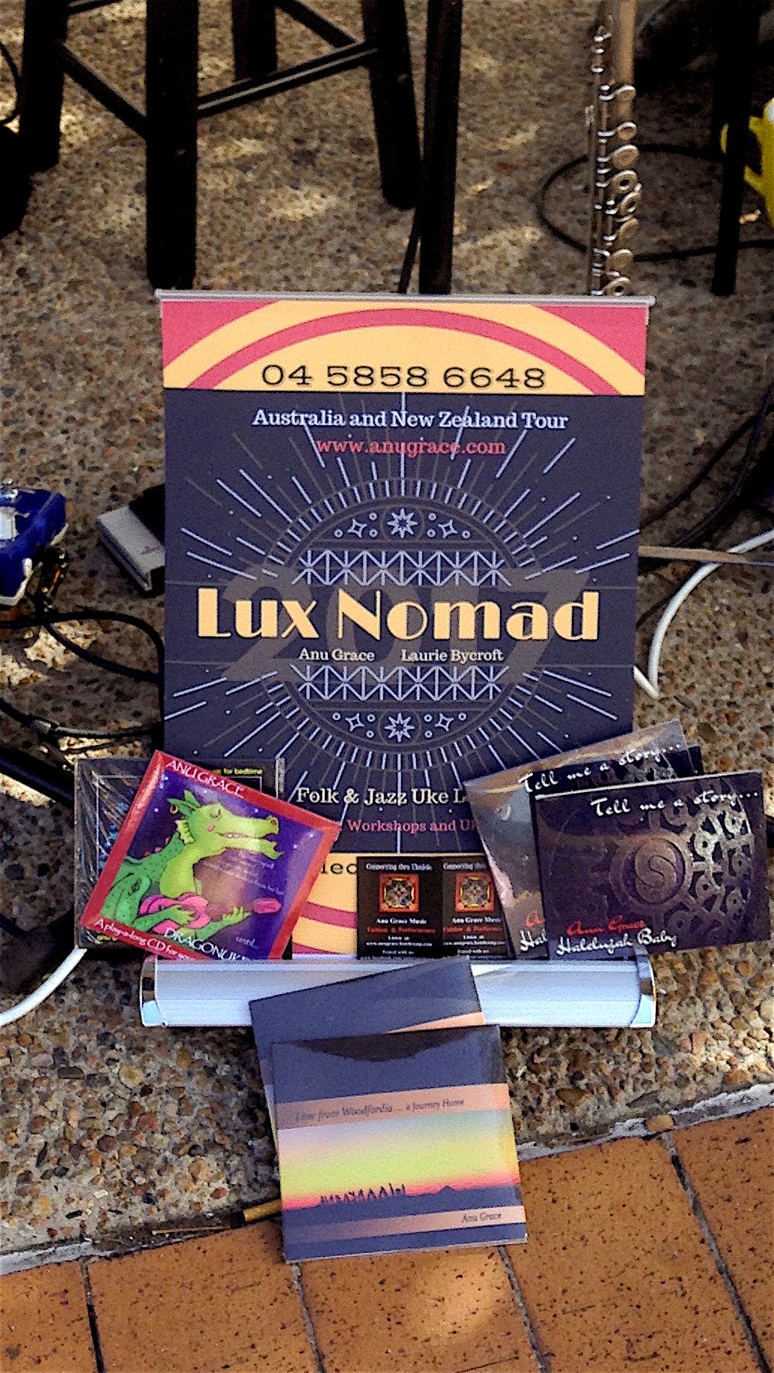
Here’s is a link to Fran Synder’s Ideas about House Concerts – sorry it’s a bit American
http://youtube.com/watch?v=try-z4-4h04

